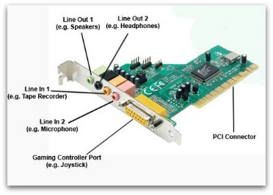Internal components of a computer

Sound card- the sound card allows the user using the computer to hear sounds like music or sound on a video.

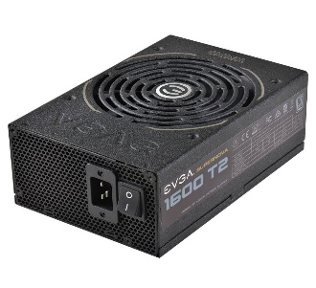

PSU- the power supply unit is used to power all the other components in the computer so they can work at the max power.

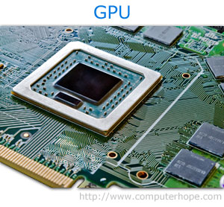

GPU- the GPU is used to make the things in which you are displaying on the monitor look better and the images and videos look better.

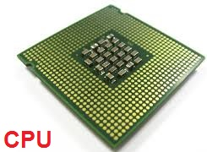

CPU- the CPU is the primary component of a computer and it is used to process instructions on the computer and it runs the operating system and applications.

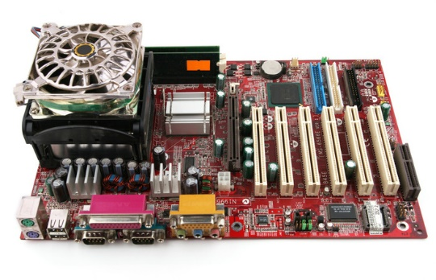

Mother board- the mother board id used to hold the components of a computer like the CPU, GPU, PSU, RAM, HDD and SSD and it can hold much more than that.

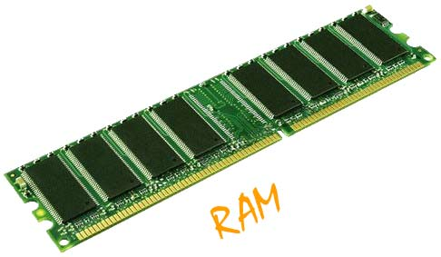

RAM- it is the place in a computing where the operating system and the application programs and data in current use are kept so they can be quickly reached by the computers processor.

Fan/Heatsink- the fan is used to cool down the processer of the computer so it does not over heat. And the heatsink is

HDD-

SSD-

Cooling systems-